LDC NIC MDC
Less Developed Country Newly Industrialized Country More Developed Country
Mostly Primary sector Mostly Secondary sector Mostly Tertiary Sector
Periphery Semi-Periphery Core
3rd World 2nd World 1st World
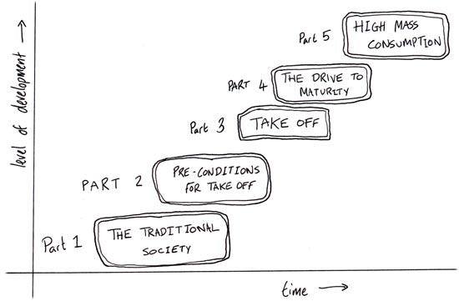
STAGE 5
Age of Mass Consumption

STAGE 4
Drive to Maturity

STAGE 3
Takeoff
STAGE 2
Preconditions for Takeoff

STAGE 1
Traditional Society

