AS

I

A

MAP

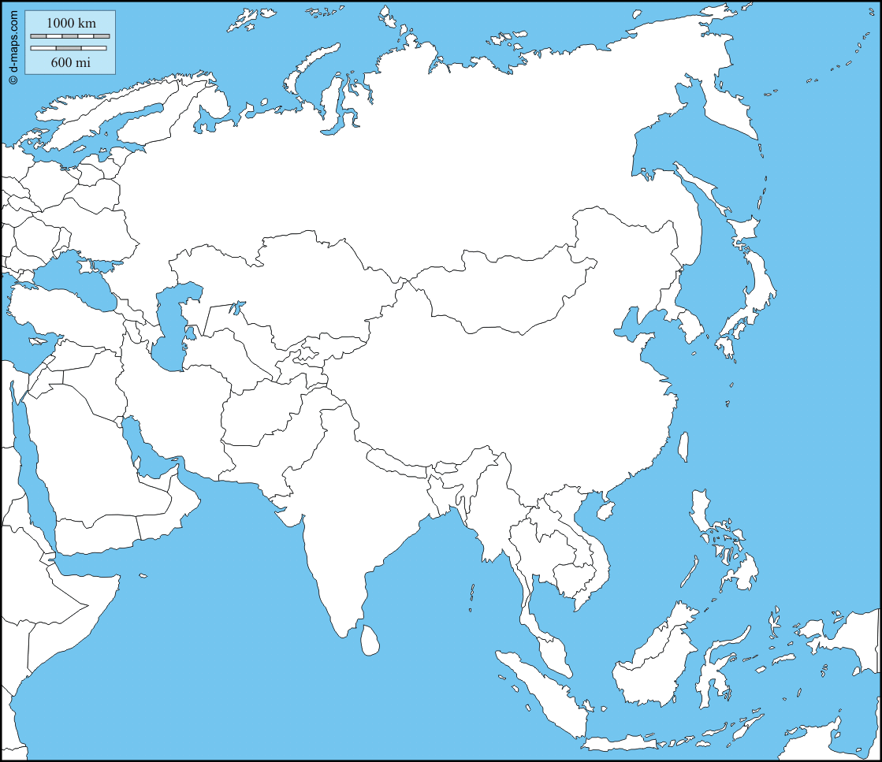

AS

I

A

MAP

