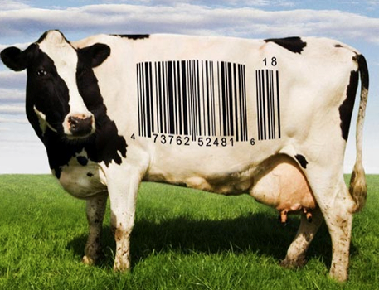
Name:
FOOD INC.
Place yourself on the following scale.

“I’LL BUY WHAT
I LIKE TO EAT,
NO MATTER WHO
MAKES IT OR HOW
IT’S MADE.”
“I’LL ONLY BUY
FOOD FROM SOURCES
WHOSE VALUES
I AGREE WITH.”

1 2 3 4 5

Explain your ABOVE position in three or four sentences.
_____________________________________________________________________________________
_____________________________________________________________________________________
_____________________________________________________________________________________
_____________________________________________________________________________________
_____________________________________________________________________________________
_____________________________________________________________________________________
_____________________________________________________________________________________
How has the film affected your perspective on the food industry?
_____________________________________________________________________________________
_____________________________________________________________________________________
_____________________________________________________________________________________
_____________________________________________________________________________________
_____________________________________________________________________________________
_____________________________________________________________________________________
_____________________________________________________________________________________

