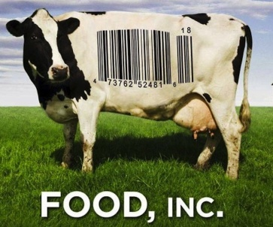
WHAT CAN YOU DO?

Here are some ideas:
You can vote to change this system. Three times a day.
• Buy from companies that treat workers, animals, and the environment with respect.
• When you go to the supermarket, choose foods that are in season. Buy foods that are organic. Know what’s in your food. Read labels.
• The average meal travels 1,500 miles from the farm to the supermarket. Buy foods that are grown locally. Shop at farmers’ markets. Plant a garden. (Even a small one.)
• Cook a meal with your family and eat together.
• Everyone has a right to healthy food. Make sure your farmers’ market takes food stamps. Ask your school board to provide healthy school lunches.
• The FDA and USDA are supposed to protect you and your family. Tell Congress to enforce food safety standards and re-introduce Kevin’s Law.
• If you say grace, ask for food that will keep us and the planet healthy. You can change the world with every bite.

Here’s some websites to look further:
http://www.takepart.com/foodinc
http://www.pbs.org/pov/foodinc/
http://www.epicurious.com/articlesguides/seasonalcooking/farmtotable/seasonalingredientmap
http://www.monsanto.com/food-inc/Pages/default.aspx (Monsanto’s answer to Food Inc.)
http://www.safefoodinc.org/index.php (Critics: “Myths & Facts” by the American Meat Institute)
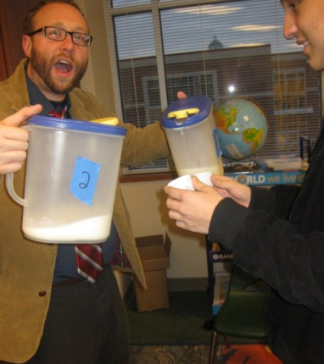
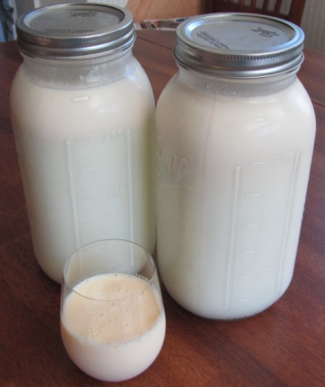
http://www.eatwellguide.org/i.php?pd=Home
http://www.happycow.net/
http://www.localharvest.org/
http://www.organicconsumers.org/
Healthy Way Dairy (Sally Milk!)
15525 Cedar St
Santa Fe, TX 77517
(409) 925-7070
https://www.facebook.com/healthyway.dairy
http://www.realfoodhouston.com/2012/01/02/milk-is-plentiful-at-healthy-way-dairy/
Resources
For additional information on the issues and topics raised by the film:
Center for Ecoliteracy (2008). Big ideas: Linking Food, Culture, Health, and the
Environment. Berkeley: Learning in the Real World. www.ecoliteracy.org.
Food and Agriculture Organization (FAO) of the United Nations (2008). The State of Food and Agriculture, 2008—Biofuels: Prospects, Risks and Opportunities. www.fao.org/publications/sofa/index_en.html
Food and Agriculture Organization (FAO) of the United Nations (2003–2004).
The State of Food and Agriculture, 2003–2004—Agricultural Biotechnology: Meeting the Needs of the Poor? www.fao.org/publications/sofa/index_en.html
Garcia, Deborah Koons (2004). The Future of Food. Lily Films.
Monsanto Company website. www.monsanto.com.
Participant Media (2009). Food, Inc: How Industrial Food is Making Us Sicker, Fatter and Poorer—and What You Can Do about It. Weber, Karl, editor. New York: Public Affairs.
Pollan, Michael (2008). In Defense of Food: An Eater’s Manifesto. New York: Penguin.
Pollan, Michael (2006). The Omnivore’s Dilemma: A Natural History of Four Meals. New York: Penguin.
Polyface Farms website. www.polyfacefarms.com.
Pringle, Richard (2005). Food, Inc.: Mendel to Monsanto—The Promises and Perils of the Biotech Harvest. Simon and Schuster.
Richardson, Jill (2009). Recipe for America: Why our Food System is Broken and
What We Can Do To Fix it. Brooklyn, NY: Ig Publishing.
Schlosser, Eric (2001). Fast Food Nation: The Dark Side of the All-American Meal. New York: Houghton Mifflin.
Singer, Peter, and Mason, Jim (2006). The Way We Eat: Why our Food Choices Matter. Emmaus, PA: Rodale.
Smithfield Foods Company website. www.smithfieldfoods.com.
Stonyfield Farm Organic Yogurt website. www.stonyfield.com.
Sustainable Table. Eat well guide. www.sustainabletable.org.
Tasch, Woody (2008). Inquiries into the Nature of Slow Money: Investing as if Food, Farms, and Fertility mattered. White River Junction, VT: Chelsea Green.

Vocabulary

Antibiotic resistance The ability of bacteria and other microorganisms to survive and multiply in the presence of an antibiotic compound that once killed them.
Blacklist To put on a list of people to be shunned, banned, or rejected.
CAFO (confined animal feeding operation) An animal feedlot operation with more than 1,000 animals at a time.
E. coli (Escherichia coli) A group of bacteria that live inside the intestines of humans, other mammals, and birds.
Feedlot A building or stockyard where livestock is fattened for market.
GMO (genetically modified organism) An organism whose DNA has been deliberately altered by laboratory methods.
Grain -fed (vs. grass-fed) Livestock raised on a diet of corn, soybeans, and other by-products, rather than pasture or grass.
Intellectual property Creations of the mind—such as music, art, writing, inventions, symbols, images, designs, or names—that have commercial value.
Libel (also called defamation, slander, or vilification) Spreading negative information about someone or something.
NAFTA (North American Free Trade Agreement) A 1994 treaty among Mexico, Canada, and the United States aimed at promoting greater trade among the three countries.
Organic food Food produced without synthetic pesticides, artificial fertilizers, hormones, antibiotics, or genetic modification.
Patent A document granting the inventor sole rights to an invention and allowing the inventor to stop others from making, using, or selling the invention.
rBST-free Dairy products produced without the use of the bovine growth hormone rBST (recombinant bovine somatotropin).

