APHuG Name: Date:

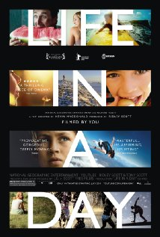
Life in a Day is a crowd-sourced drama/documentary film comprising an arranged series of video clips selected from 80,000 clips submitted to the YouTube video sharing website, the clips showing respective occurrences from around the world on a single day, July 24, 2010.
The film is 94 minutes 53 seconds long and includes scenes selected from 4,500 hours of footage in 80,000 submissions from 192 nations. The completed film debuted at the Sundance Film Festival on January 27, 2011 and the premiere was streamed live on YouTube.

Answer the following questions they asked:
What do you have in your pocket/bag?
______________________________________________________________________________
______________________________________________________________________________
______________________________________________________________________________
______________________________________________________________________________
What do you love?
______________________________________________________________________________
______________________________________________________________________________
______________________________________________________________________________
______________________________________________________________________________

What do you fear?
______________________________________________________________________________
______________________________________________________________________________
______________________________________________________________________________
______________________________________________________________________________

