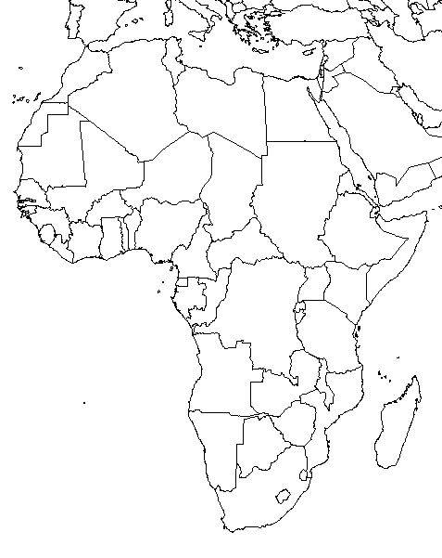

Algeria
Angola
Benin
Botswana
Burkina Faso
Burundi
Cameroon
Cape Verde
Central African Republic
Chad
Comoros
Congo
Democratic Republic of the Congo

Cote d'Ivoire
Djibouti
Egypt
Equatorial Guinea
Eritrea
Ethiopia
Gabon
Gambia
Ghana
Guinea
Guinea-Bissau
Kenya
Lesotho
Liberia
Libya
Madagascar
Malawi
Mali
Mauritania
Mauritius
Morocco
Mozambique

Namibia
Niger
Nigeria
Rwanda
Sao Tome and Principe
Senegal
Seychelles
Sierra Leone
Somalia
South Africa
South Sudan
Sudan
Swaziland
Tanzania
Togo
Tunisia
Uganda
Zambia
Zimbabwe

