North Korea begins brainwashing children in cult of the Kims as early as kindergarten
By Anna Fifield January 16
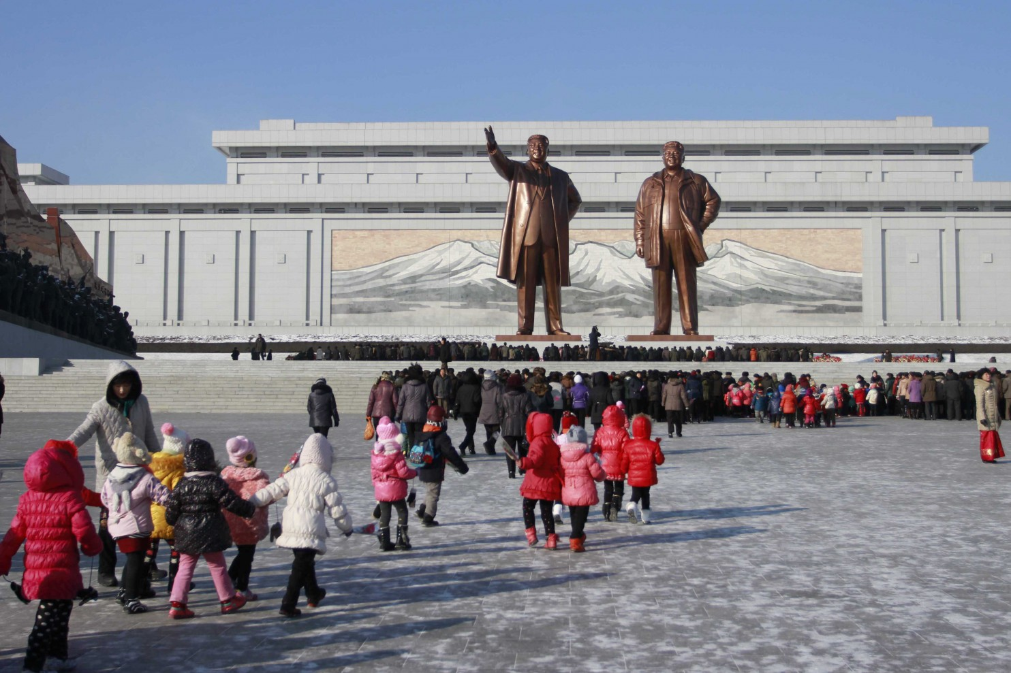
SEOUL — When Jeon Geum­ju was a girl in Hoeryong, a depressing mining town at the very northern reaches of North Korea, she used to sing at school about the country’s supreme leader.
“Kim Jong Il, how hard he works, he works so hard that he sleeps in the car and just eats rice balls,” sang Jeon, now 29, sitting in a restaurant here trying to recall the words that were once ingrained into her. “On his desk there are piles and piles of reports that he has to read and approve. He works so hard for us, the people.”
And when Lee Hyun­ji, 19 and also from the country’s north, was in elementary school, learning to throw wasn’t a simple matter of pitching a ball. In gym class, there was a wooden target of a human figure with pale skin and a huge nose, with “cunning American wolf” written on it. Lee and her young schoolmates would practice their throwing with a wooden “grenade.”
For North Korea’s dynastic Kim regime, citizens are never too young to be indoctrinated. Indeed, an all­encompassing personality cult has kept the country intact even as the Soviet Union collapsed and as China and Cuba have opened up. With its pudgy leaders and their comical haircuts, its goose­stepping soldiers and its inventive turns of phrase, this bastion of totalitarianism has provided endless opportunity for mockery, most recently with the controversial U.S. film “The Interview.”
Although critics have questioned its artistic merits and defectors have lamented the way it makes fun of North Koreans, the movie targets a central tenet of Kimist mythology: the idea that the North’s leaders are divine beings. The crucial moment in the film is not the death of Kim Jong Un but earlier, when a talk show host interviews Kim and taps into his daddy issues, leading the young dictator to start blubbering, “I am strong,” revealing him to be not only human but also insecure.
The personality cult that permeates every aspect of North Korean life has become an ideology in itself. It revolves around Kim Il Sung, portrayed as an anti­Japanese revolutionary hero and founding father who remains North Korea’s “eternal president” more than two decades after his death.
His son, Kim Jong Il, was, according to North Korean myth, born on a sacred mountain, under a bright star at night. (In reality, he was born in Siberia.) Since Kim Jong Il’s death in 2011, Kim Jong Un has taken over the family business.
“I believed in this system for more than 20 years, but I was so thirsty to find out about the outside world,” said Jeon, who now lives in South Korea and works in an office. Her curiosity led her to decide to sneak across the border to China. “Then, when I realized it was all lies, it was like I was just born at 23 years old. Twenty­three years had been stolen from my life.”
365 days’ worth of Kims
In North Korea, there is no escaping the Kims. Every home, office, classroom and even train car features portraits of the first two leaders, and the pictures must be cleaned with a special cloth every day.North Koreans wear pins, usually of Kim Il Sung but sometimes of both Kim One and Kim Two, on their chests, on the left to be close to their hearts.
Television sets and radios are fixed to state­run channels — being caught with an unfixed device, or worse, foreign DVDs, is a severe offense that often leads to time at a labor camp — and for all but a handful of the elite, there is no Internet. Although an increasing amount of information seeps across the border from China, the state continues to have almost total control over the flow information.
After years of futile efforts to stop North Korea from developing nuclear weapons, the international community is now focused on human rights violations there. Unprecedented attention is being given to political imprisonment and executions. More pervasive, but less obviously gruesome, is the way the regime brainwashes children from an early age to believe in the Kims as godlike leaders.
This indoctrination program has two basic goals, according to a groundbreaking 372­page report published last year by a U.N. commission of inquiry: to instill utmost loyalty and commitment toward the supreme leader, and to instill hostility and deep hatred toward the United States, Japan and South Korea.
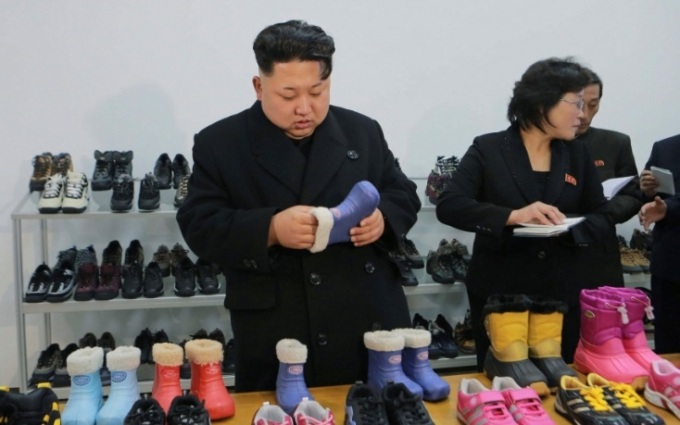
The brainwashing starts in kindergarten.
“The milk would arrive and we would go up one by one to fill our cups,” recalled Lee, who came to South Korea only in March and asked to use a pseudonym to protect her family in the North. “The teachers would say: ‘Do you know where the milk came from? It came from the Dear Leader. Because of his love and consideration, we are drinking milk today,’ ” said Lee, looking every bit a South Korean with her dyed hair and trendy sweater.“I didn’t really ask questions,” she shrugged. “Somehow I just knew not to.”
Children’s books convey the ideology, too. “The Butterfly and the Cockerel,” for example, tells the story of an irascible, bullying rooster (the United States) outwitted by a small, virtuous butterfly (North Korea). Teachers don’t just teach history, they teach “revolutionary history.” And all music, storybooks, novels and artwork relate to the Kims.
“When I taught math problems, they would go like this,” said Chae Kyung­hee, who used to teach middle school in North Korea and now runs a school for defectors in Seoul. “If you have this many of Kim Il Sung’s anti­Japanese fighters and this many Japanese soldiers, and X­many Japanese soldiers are killed ...”
There are 365 days’ worth of education materials, so every day teachers could say to their students, “On this day, Kim Il Sung went there, did that.” At age 7, all children must join the Children’s Union. The next year, they start Saturday “self­criticism” sessions in which they must confess how they fell short of the “Ten Principles” that are the foundation of North Korea’s ideology. The principles include requirements such as studying the “revolutionary ideas of Great Leader Comrade Kim Il Sung” daily.
At 14, they move up to the Kim Il Sung Socialist Youth League, which focuses on worshiping the Kim family.
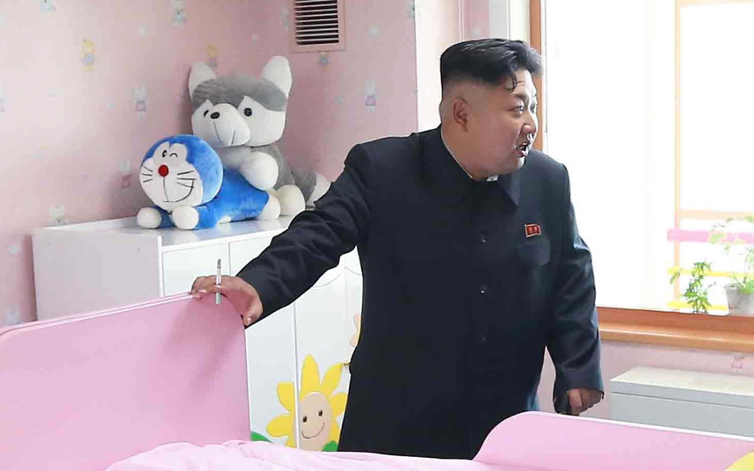
High school students in North Korea must complete a three­year, 81­hour course on the history of Kim Jong Un, according to a recent report from South Korea’s KBS World Radio, which cited a copy of the North Korean Education Committee’s “compulsory education outline.” The course is in addition to a 160­hour course on Kim Il Sung and 148 hours of study about Kim Jong Il.
Social molding
Sweet
Cigarette
Tatiana Gabroussenko, an expert on North Korean literature who teaches at Korea University in Seoul, said that by not allowing people to form their own opinions, North Korea infantilizes its citizens.
“North Korea molds children socially,” Gabroussenko said. Books for different generations have different styles but the same message and characters, sometimes involving South Korean “stooges” or American “beasts.”
“In the children’s version, a child will be fighting Americans by throwing pepper in their eyes and making them sneeze and cough,” Gabroussenko said. In the adult version, weapons, rather than condiments, are used.
“The message ‘We are one nation’ implies that you can’t rebel against your father, you can’t rebel about your government, that it’s important to stick together,” she said.
Indeed, the system of surveillance and informing on people is so pervasive that husbands dare not voice doubts about the regime to their wives, and parents, if they are skeptical, dare not try to protect their children’s minds.
“My parents were very loyal,” said Ji Sung­ho, a 31­year­old who lost a foot and an arm as a teenager when he fell from a moving train while trying to steal coal for his family. “I think my parents really believed it, even when people were dying of hunger.”
The U.N. report concluded that the system of indoctrination and surveillance constitutes numerous human rights abuses, including violations of the freedoms of thought, expression and religion. To some, those violations are just as inexcusable as the executions, torture, infanticide and other abuses documented in the report.
“Of course, you can talk about torture and labor camps,” said Jeon, the defector, “but I think a more serious infringement of human rights is not giving people any choice to think for themselves or giving them access to outside information.”
Anna Fifield is The Post’s bureau chief in Tokyo, focusing on Japan and the Koreas. She previously reported for the Financial Times from Washington DC, Seoul, Sydney, London and from across the Middle East.
APHuG Name: Per: Date:
After watching the program “Inside North Korea” and discussing with your neighbors, respond to the following:
What should the world community do with North Korea? Come up with 2 options and explain how that option will affect North Korea and the neighboring Asian countries (especially South Korea).

Option #1
________________________________________________________________________________________________
________________________________________________________________________________________________
________________________________________________________________________________________________
________________________________________________________________________________________________
________________________________________________________________________________________________
________________________________________________________________________________________________
________________________________________________________________________________________________
________________________________________________________________________________________________

Option #2
________________________________________________________________________________________________
________________________________________________________________________________________________
________________________________________________________________________________________________
________________________________________________________________________________________________
________________________________________________________________________________________________
________________________________________________________________________________________________
________________________________________________________________________________________________
________________________________________________________________________________________________

