THE FOOD LIST CHALLENGE – 100 great foods that must be tried

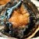 | 1. Abalone
 | 2. Absinthe
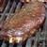 |  | 3. Alligator
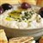 |  | 4. Baba Ghanoush
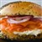 |  | 5. Bagel and Lox
 |  | 6. Baklava
 |  | 7. Barbecue Ribs
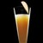 |  | 8. Bellini
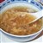 |  | 9. Bird's Nest Soup
 |  | 10. Biscuits and Gravy
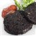 |  | 11. Black Pudding
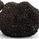 |  | 12. Black Truffle
 |  | 13. Borscht
 |  | 14. Bread Pudding
 |  | 15. Calamari
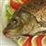 |  | 16. Carp
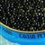 |  | 17. Caviar
 |  | 18. Cheese Fondue
 |  | 19. Chicken and Waffles
 |  | 20. Chicken Tikka Masala
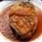 |  | 21. Chile Relleno
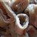 |  | 22. Chitlins
 |  | 23. Churros
 |  | 24. Clam Chowder
 |  | 25. Cognac
 |  | 26. Crab Cakes
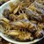 |  | 27. Crickets
 |  | 28. Currywurst
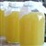 |  | 29. Dandelion Wine
 |  | 30. Dulce De Leche
 |  | 31. Durian
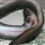 |  | 32. Eel
 |  | 33. Eggs Benedict
 |  | 34. Fish Tacos
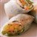 |  | 35. Fresh Spring Rolls
 |  | 36. Fried Catfish
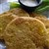 |  | 37. Fried Green Tomatoes
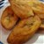 |  | 38. Fried Plantain
 |  | 39. Frito Pie
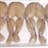 |  | 40. Frogs’ Legs
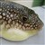 |  | 41. Fugu
 |  | 42. Funnel Cake
 |  | 43. Gazpacho
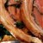 |  | 44. Goat
 |  | 45. Goat’s Milk
 |  | 46. Goulash
 |  | 47. Gumbo
 |  | 48. Haggis
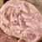 |  | 49. Head Cheese
 |  | 50. Heirloom Tomatoes
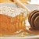 |  | 51. Honeycomb
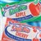 |  | 52. Hostess Fruit Pie
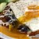 |  | 53. Huevos Rancheros
 |  | 54. Jerk Chicken
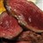 |  | 55. Kangaroo
 |  | 56. Key Lime Pie
 |  | 57. Kobe Beef
 |  | 58. Lassi
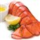 |  | 59. Lobster
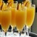 |  | 60. Mimosa
 |  | 61. MoonPie
 |  | 62. Morel Mushrooms
 |  | 63. Nettle Tea
 |  | 64. Octopus
 |  | 65. Okra
 |  | 66. Oxtail Soup
 |  | 67. Paella
 |  | 68. Paneer
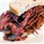 |  | 69. Pastrami on Rye
 |  | 70. Pavlova
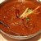 |  | 71. Phaal
 |  | 72. Philly Cheese Steak
 |  | 73. Pho
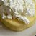 |  | 74. Pineapple and Cottage Cheese
 |  | 75. Pistachio Ice Cream
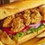 |  | 76. Po’ Boy
 |  | 77. Pocky
 |  | 78. Polenta
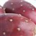 |  | 79. Prickly Pear
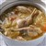 |  | 80. Rabbit Stew
 |  | 81. Raw Oysters
 |  | 82. Root Beer Float
 |  | 83. S’mores
 |  | 84. Sauerkraut
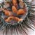 |  | 85. Sea Urchin
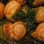 |  | 86. Snail
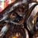 |  | 87. Snake
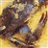 |  | 88. Soft Shell Crab
 |  | 89. Som Tam
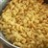 |  | 90. Spaetzle
 |  | 91. Spam
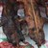 |  | 92. Squirrel
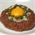 |  | 93. Steak Tartare
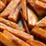 |  | 94. Sweet Potato Fries
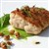 |  | 95. Sweetbreads
 |  | 96. Tom Yum
 |  | 97. Umeboshi
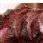 |  | 98. Venison
 |  | 99. Wasabi Peas
 |  | 100. Zucchini Flowers

