AP Human Geography
9 Week Test - UNIT 2 Exam - Study Guide
Population & Migration
VOCABULARY:
demography, overpopulation, census, ecumene, arithmetic/population density, physiological density, agricultural density, crude birth rate, crude death rate, natural increase rate (NIR/NRI/RNI), doubling time, total fertility rate, mortality, population pyramid, dependency ratio, sex ratio, demographic transition model, agricultural revolution, Industrial Revolution, medical revolution, zero population growth, epidemiologic transition, epidemic, epidemiology, pandemic, one-child policy, infant mortality rate, life expectancy, population J-curve (L-curve), population S-curve, eugenics, carrying capacity, baby boom, migration, mobility, circulation, emigration, immigration, net migration, migration transition, international migration, voluntary migration, forced migration, internal migration, interregional migration, intraregional migration, counterurbanization, push factor, pull factor, refugee, internally displaced person (IDP), asylum seeker, guest worker, intervening obstacle, intervening opportunity, quotas, brain drain, chain migration, unauthorized/illegal/undocumented immigrants, amnesty, remittance, Rust Belt, Sun Belt

Be familiar with all aspects of what was covered in Unit 2-3 including:
U.S. Immigration Patterns (p. 82—83), Thomas Malthus’ theories, population pyramids, demographic transition stages (CBR, CDR, NIR, etc), “Graying of America,” Ravenstein’s 11 Laws of Migration.
Where is most of the population growth happening in the world?

What is the difference between net in and net out migration?

What are the Top 3 most populous countries?

What are the top 4 populous regions? What would be the 5th?

What climates/biomes do human beings avoid?
Why did Irish migrate to the US in the 1840s?

Where do Americans migrate intraregionally currently? (suburban, urban, rural?)
What are the most important pull factors for migrants to North America?

What is the motive for suburbanization in developed countries?

What factor usually causes voluntary migration?

Why did Europeans migrate to the United States?

What part of Europe migrated to the United States during the peak of the late 19th century?

What part migrated to U.S. during the early 20th century?

What effect did U.S. quota laws from the 1920s – 1960s have on migrants?

How does a migrant’s country of origin and economic prospects direct their choice of migration?

What does Africa’s low rate of contraceptive use tell about women’s status?

What is the political purpose for the United States census’?
What is “arable land?”

Explain the Agricultural Revolution and affects on population:

Explain the Industrial Revolution and affects on population:

Explain the Medical Revolution and affects on population:

What is the “Graying of America” and what challenges does it present?

How has the center of America’s population changed over its history?

What are some challenges faced in the illegal immigration debate between Mexico and the United States?

What was the 1986 Immigration Reform and Control Act?
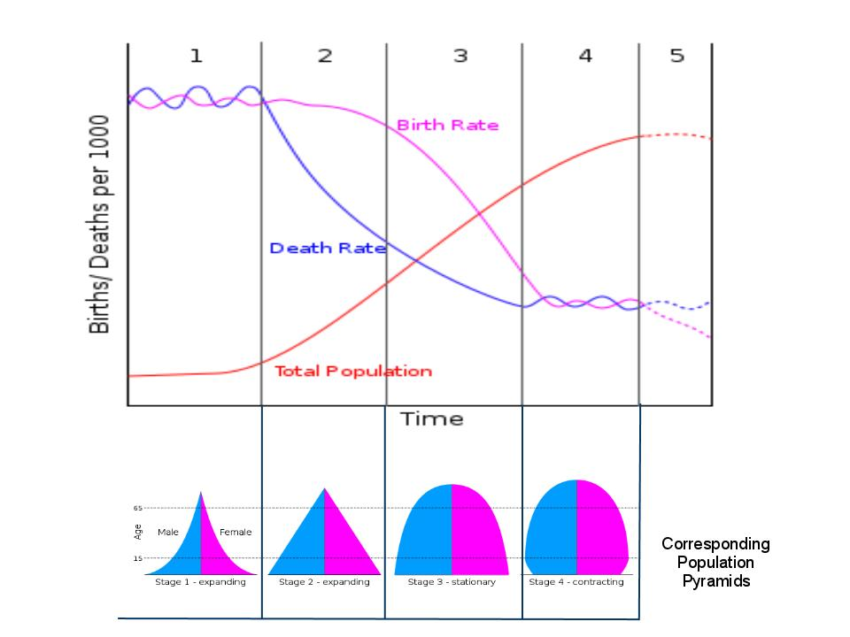
Explain what is happening in each of the 5 stages and give an example country.
Stage 1:

Stage 2:

Stage 3:

Stage 4:

Stage 5:

