World Geography Name: Date:

**West Africa, Slavery, Imperialism, Problems notes**

**3 “G’s” of Exploration**

GOD, GOLD AND GLORY

God – To spread ______________. Gold – To find new items to ______________ and new markets to ______________. Glory – to make a name, name places, adventure!

Which of the following do you think was the largest driving force for explorers?

**European’s 1st West Africa Interest**

**Discovering** ____________________________**to Asia.**

____________________________ AD 1497 – sails to India

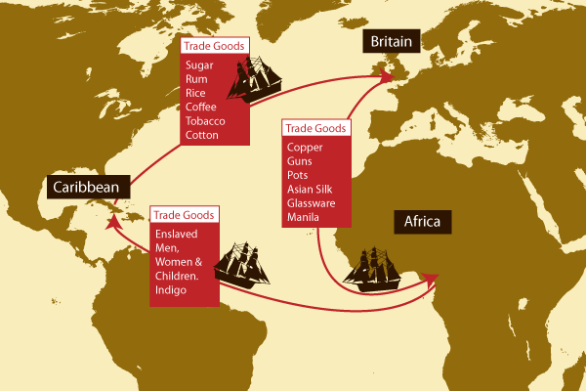West coast of Africa = ______________ (originally called)

**Triangular Trade**

What left Africa to the Americas?

What left the Americas to Europe?

What left Europe to Africa?

**Africa – What is up?**

Beginning of ______________?

Early strong trading civilizations? - ______________, ______________ and ______________

Natural Resources!!! Exploitation by ______________ Exploitation by ______________

Chaotic Structures – ______________, socially

______________, Genocide, ______________, and oh yeah, Exploitation (Oil, Diamonds, Gold, Etc.)

What are North Africa’s main Natural Resources?

Where are the diamonds in Africa?

About how many countries don’t have some type of natural resource?

Which countries have the most oil in Africa?

**“The White Man’s Burden”**

Concept that was used to ______________ ______________ ______________ in the world.

One view proposes that white people have an ____________________________, and encourage the ______________ ______________ of people from other cultural backgrounds until they can take their place in the world ____________________________.

The term "the white man's burden" has been interpreted by some as ______________, or possibly taken as a metaphor for a condescending view of undeveloped national culture and economic traditions, identified as a sense of European superiority which has been called "cultural imperialism".

An alternative interpretation is the philanthropic view that the ______________ ______________ and obligation to ______________ ___________"better" themselves whether the poor want the help or not.

**Berlin Conference 1884-85**

In 1884 at the request of Portugal, German chancellor Otto von Bismark called together the ______________ ______________ ______________ of the world to negotiate questions and end confusion over the ____________________________.

Fourteen countries were represented by a plethora of ambassadors when the conference opened in ______________ on November 15, 1884.

At the time of the conference, ______________ _________remained under traditional and local control. What ultimately resulted was a hodgepodge of geometric boundaries that originally ______________ __________________________________________.

This new map of the continent was superimposed over the ____________________________ ______________ and regions of Africa. The new countries lacked rhyme or reason and divided groups of people and ______________ together different __________________________________________.

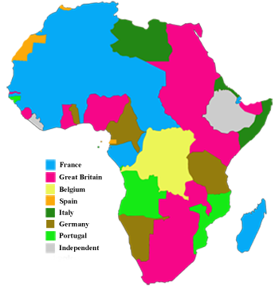**Label what European country controlled which regions and color them in distinctly different (8 colors).**

4

**Which countries**

5

4

**controlled most**

1

**of Africa?**

6

6

3

2

7

2

1

6

2

2

2

Color the number boxes too.

4

8

8

8

7

7

7

6

6

5

5

5

4

3

2

2

2

1

1